EX NO:14
DATE:
STUDENT ACADEMIC PERFORMANCE SEGMENTATION

AIM: To analyze student academic performance using the Student Academic Data.xlsx dataset in Tableau by creating Good, Average, and Bad performance segments for both Math Test and Writing Test scores.
Using the “Student Academic Data.xlsx”, create segments of Good, Average and Bad performance in “Math test” and “Writing test”.
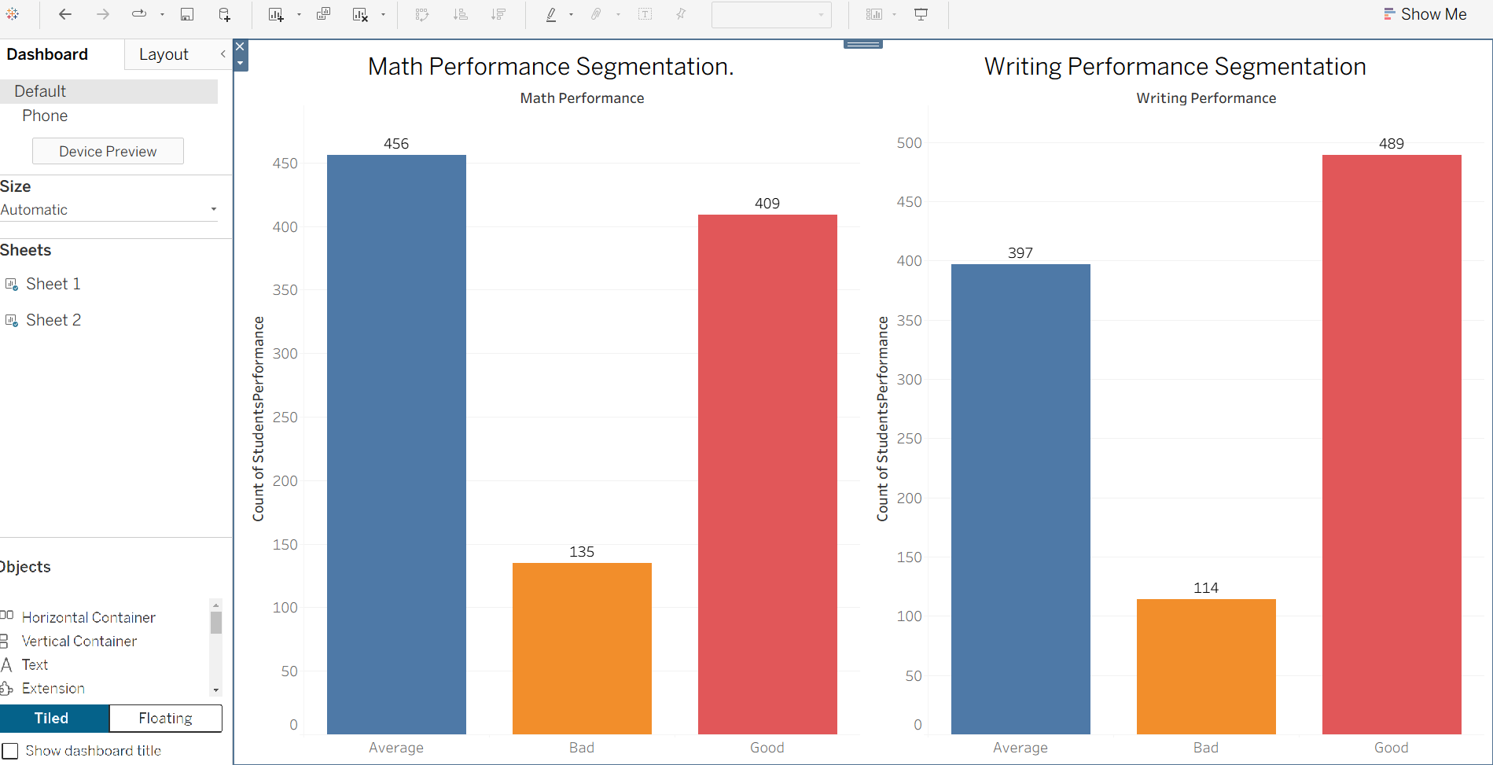
INTERPRETATION:
The visualization categorizes students into Good, Average, and Bad performance segments based on their Math Test and Writing Test scores. It helps compare student performance across both subjects, identify high- and low-performing students, and understand differences in academic achievement. This analysis supports the identification of students who may need additional academic support and helps improve learning outcomes.

